Business Context
In the highly competitive e-commerce space, delivering excellent customer service is crucial for sustaining growth and customer loyalty. Flipkart, as one of the largest e-commerce platforms, focuses on enhancing customer satisfaction to differentiate itself from competitors. The dataset in this project captures customer interactions, feedback, and satisfaction scores across various support channels at Flipkart. By analyzing these interactions, the goal is to identify key drivers of customer satisfaction, understand performance across different customer service teams, and develop strategies to improve the overall service experience.
Understanding factors that influence customer satisfaction will allow Flipkart to not only resolve customer issues faster but also tailor its support strategies to meet diverse customer expectations. This will help in optimizing the performance of service agents and improving satisfaction metrics like the CSAT score, ultimately leading to increased brand loyalty and customer retention.
Dataset Description
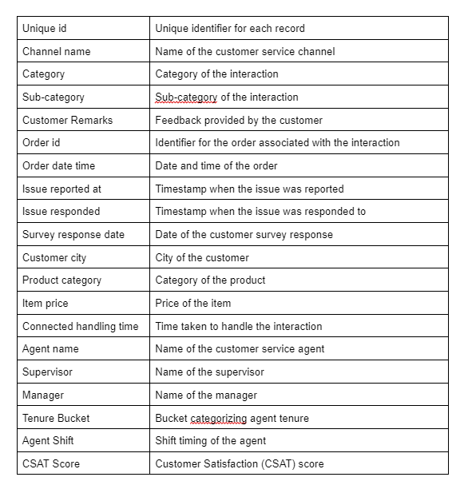
Project Architecture:
- Pandas: For data manipulation, cleaning, and analysis.
- NumPy: For numerical operations and handling large datasets.
- Matplotlib & Seaborn: For data visualisation to identify trends and insights.
- Scikit-learn: For implementing machine learning classification algorithms and model evaluation.
- Faker (If required ): Used to generate synthetic data and anonymize sensitive information in the dataset.
Project Architecture: